AI-Enhanced vs Legacy DFIR Tool Application and Reporting
Byte harbor butchers
Results, Findings, and Recommendations
Matt Baker, sam davies, Olivia hey, dave sushames
2026

Executive Summary
LLMs
Table of Contents
Executive Summary 1
Background 2
Research Limitations 2
DFIR 2
Testing Environment 2
Tools 2
Test Cases 2
Findings 2
Data Types 2
Limitations of humans 3
Limitations of LLMs 3
Foremost 3
Nmap 3
Wireshark 3
Recommendations 3
References 3

Background

Research Limitations
For this investigation

DFIR

Testing Environment

Tools

Test Cases
 | Foremost | Nmap | Wireshark
File Type | .DD/.TXT | .XML/.TXT | .PCAP/NG
Converted to | .TXT | .TOON | .CSV
Case File 1 | Three.dd | Nmap_example.xml | evidence01.pcap
Case File 2 | EIGHT.dd | SOITnetworkscan.xml | evidence02.pcapng
Case File 3 | NINE.dd | 28sepServiceScan.xml | evidence03.pcap

Findings

Data Types

Foremost

Nmap

Wireshark
Wireshark presents the largest investigable datasets in the form of network packet captures. This data includes source/destination IP, frame numbers, and info column contents for every single network packet captured, in some datasets numbering in the tens of thousands. The impact of this was mitigated by exporting the Wireshark packet dissections that would be most relevant to an LLM analyst with “tshark” and feeding that data directly to an Ollama model as a CSV file. Ollama and Gemma4 still struggled greatly with the sheer size of input data despite 30k context capacity and prompt chunking, which came out in the quality of the reports.

In this example below, the AI hallucinates the packet range it was explicitly asked for (1) and is unable to fully reassemble a message that appears from the subject typing one character at a time (2), the original message was “iknowyouarewatching” but it fails to identify this, likely due to the LLM having to keep in mind a large string of TCP packet data.
Figure 1
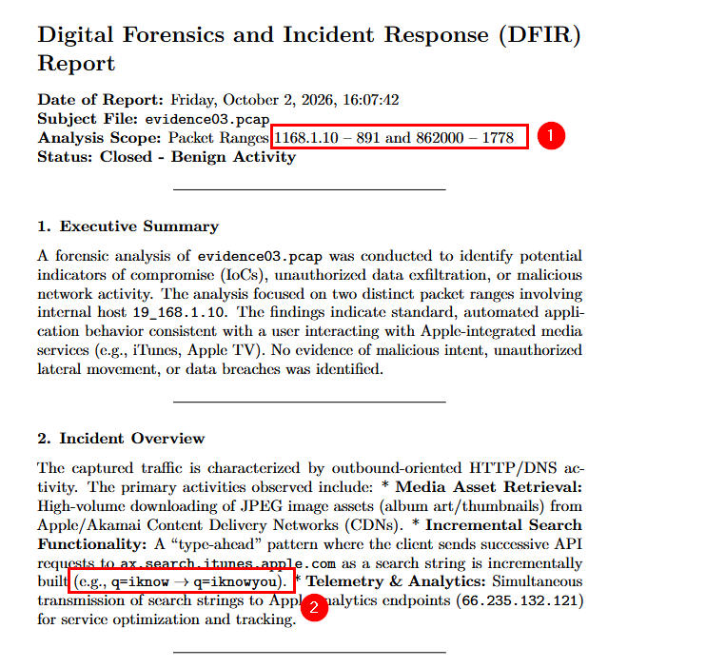

Limitations of humans

Limitations of LLMs

Foremost

Nmap

Wireshark

Recommendations

References
There are no sources in the current document.

